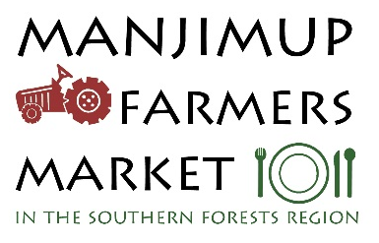

ABN 79 736 494 543
MANJIMUP FARMERS MARKET INC.
MEMBERSHIP APPLICATION FORM 2017 -2018
Farmer, grower, manufacturer from the Shires of Manjimup, Bridgetown, Nannup and Boyup Brook only, as per the MFM charter.
Membership Benefits:
- Reduced stallholder rate for the Manjimup Farmers’ Market
- Permanent position
- Free comprehensive listing on the www.manjimupfarmersmarket.com.
- Voting rights MFM
- Promotion under the MFM banner
- Priority access to information/initiatives/workshops/events the MFM deem beneficial for its members.
Please note all applications are subject to applicants meeting the objectives of the MFM charter and approval by the MFM committee.
Date: / /
Existing member Applying for a new membership
Name of Business:_________________________________________________________________
Contact Name/s: __________________________________________________________________
Telephone:_______________________________________________________________________
Email:___________________________________________________________________________
Web site: ________________________________________________________________________
Street address: ____________________________________________________________________
Postal address:_____________________________________________________________________
Produce/Food produced: _____________________________________________________________
Producer membership: $50. NEW MEMBERS PLEASE NOTE YOUR MEMBERSHIP WILL BE ASSESSED BY THE MFM COMMITTEE. PLEASE DO NOT PAY THE MEMBERSHIP IMMEDIATELY. IF/WHEN YOUR APPLICATION IS SUCCESSFUL, YOU WILL BE CONTACTED DIRECTLY BY THE MFM TREASURER FOR PAYMENT. THANK YOU.
Payment : EFT preferred – BSB 036 126 a/c 158 211. Please include name of business.
Cheque: Treasurer, Manjimup Farmers Market, 46 Karri St Manjimup 6258

